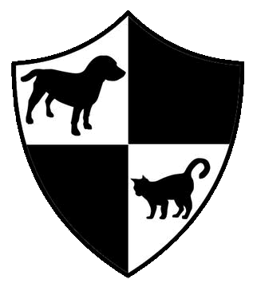CARA WELFARE Phils
Compassion and Responsibility for Animals
2365 Singalong Street, corner Dagonoy Street, Malate Manila, Telefax: 353-3381
Mobile Cell 0910-7297026

Spay and Neuter Application Form

Your Name____________________________________________________________________________

Address_______________________________________________________________________________

Landline___________ Mobile __________________ Email _____________________________________

Animals details

Female cat: Male cat: Female dog: Male dog:

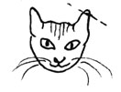 CARA routinely notches all community cats ears. Done under anesthetic the process is painless, this procedure means that a fixed cat can be identified; it is a universally recognized symbol. Thus a cat can be spared the trauma of a second trapping for neutering, as well as the risk of unnecessary anesthetic. If the cat is owned please indicate below if you would or would not like the ear notched. Any cat that goes outside should have its ear notched.

Ear Notch: Yes No

Age (approx): ______ Description (colour) of animal: ___________________________________________

Can the animal be handled safely? __________________________________________________________

______________________________________________________________________________________

I,__________________________________________, of legal age, do hereby declare that I am aware of the risks involved in surgical procedures for cats and dogs. CARA Welfare’s veterinarians and staff will exercise due diligence and care during surgical procedures of the animals under its charge; however, I understand that despite such care and diligence, surgical procedures are not without risk and that animals undergoing such procedures sometimes suffer unforeseen injuries and even death.
Thus having attested to the foregoing, I declare that I will not hold either CARA Welfare Philippines or the attending veterinarian(s) responsible in any way in the event that my pet(s) should suffer any injury or death as a result of the surgical procedures and that CARA is not responsible for a pet’s injury or death at anytime after surgery. The animal must be fully awake before leaving the clinic and each animal placed in a separate container/cage.. I state the animal has not had food for 9 hours pre-operative.

I am signing this waiver of my own free will and that I have been given written post operation care instructions.

Signature __________________ Printed name ____________________________Date _____________

------------------------------------------------------------------------------------------------------------------------------------------------

Office use only:

Amount paid: ___________________ Received by: ________________________________

